Precipitation Reactions

Introduction
The majority of ionic solids are soluble in water. Those that are not, form solid products called precipitates when two aqueous ionic solutions are mixed. Ionic compounds are made of positive and negative ions held together by the attractive, electrostatic forces that occur between oppositely charged particles. Soluble ionic compounds break apart completely into their respective ions when put in water.
Example: Sodium chloride - NaCl (s) - when put into water yields Na⁺ (aq) and Cl⁻ (aq). Silver nitrate - Ag(NO)₃ (s) - also dissociates in water to form the respective ions Ag⁺ (aq) and NO ³⁻ (aq). When these two solutions of sodium chloride and silver nitrate are mixed, a solid forms (precipitation occurs). The new mixture still contains Na⁺(aq) and NO ₃⁻(aq), however, the newly formed precipitate is silver chloride – AgCl (s). The chemist describes this process first as a complete ionic equation:
Na⁺(aq) + Cl⁻(aq) + Ag⁺(aq) + NO ₃⁻(aq) → AgCl(s) + Na⁺(aq) + NO ₃⁻(aq)
Notice that the sodium and nitrate ions appear the same on both sides of the equation, that means they did not change; therefore, they are called spectator ions. Chemists like to write a more useful equation that describes only the changes that took place. They write a net ionic equation which eliminates spectator ions.
Ag⁺(aq) + Cl⁻(aq) → AgCl (s)
Below is a solubility chart, which will help you identify which reactions will form a solid (precipitate).
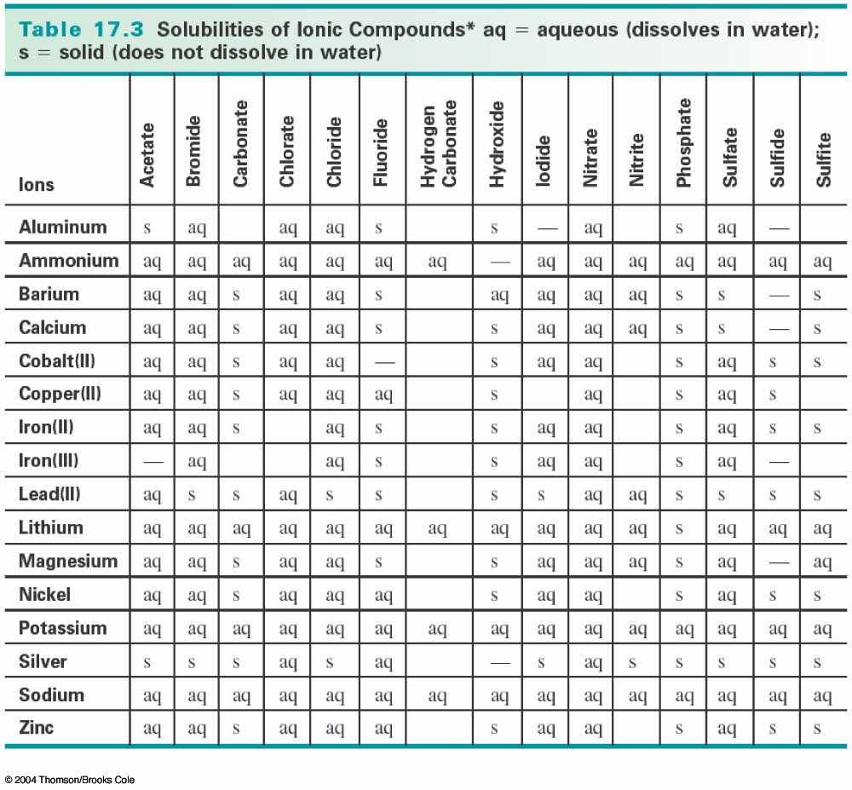

Aim:
To determine which combinations of ionic solutions form precipitates, and identify the precipitate formed in each reaction.

Hypothesis
Based on the solubility chart, determine which reactions you think will form a precipitate:

Materials:
- Well plate
- Dropper bottles with the following solutions:
Barium nitrate Potassium carbonate
Cobalt (II) chloride Sodium hydroxide
Copper (II) sulfate Potassium iodide
Iron (III) nitrate Silver nitrate
Lead (II) nitrate Sodium phosphate

Procedure:
Write your procedure below:

 | Potassium carbonate | Sodium hydroxide | Potassium iodide | Silver nitrate | Sodium phosphate | Barium nitrate | Cobalt (II) chloride | Copper (II) sulfate | Iron (III) nitrate | Lead (II) nitrate
Barium nitrate
Cobalt (II) chloride
Copper (II) sulfate
Iron (III) nitrate
Lead (II) nitrate
Potassium carbonate
Sodium hydroxide
Potassium iodide
Silver nitrate
Sodium phosphate

