the amazing solar-system

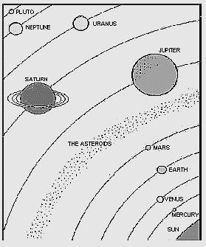
Our solar system consists of:
- Our sun! The centre of our solar system
- Eight planets that orbit the sun
- Three dwarf planets that also orbit the sun
- Over 150 moons that orbit the planets
- Countless asteroids, many in the asteroid belt
- Icy comets in highly elliptical orbits

The Astronomical Unit
Since space is so vast (big), and the distance between objects in space is very large to be easily measured in metres and kilometres, scientists use a unit of measurement called an “Astronomical Unit (AU)”. It is the average distance between the Earth and the Sun - approximately 150 million kilometres.
In 2006, the “International Astronomical Union” met in Europe and created a new class of heavenly body, the dwarf planet. It included three objects in this new category:
- Ceres – the largest asteroid in the asteroid belt
- Pluto – traditionally the ninth planet
- Eris – discovered in 2005 and larger than Pluto
Planet/Dwarf Planet | Distance in AU
Mercury | 0.4
Venus | 0.7
Earth | 1.0
Mars | 1.5
Ceres (Asteroid belt) | 2.8
Jupiter | 5.2
Saturn | 9.5
Uranus | 20.0
Neptune | 30.0
Pluto (Dwarf planet) | 40.0
Eris (Dwarf planet) | 50.0

Activity 1

Plot the Dots!
Mark the centre line to show where each planet should be:
- Use the data in the table to show distances of the planets/dwarf planets from the sun
- Write a label above the chart “Astronomical Units”
- Label below the chart 0 on the far left and 40 on the far right
- Make a “dot” along the line to show each objects average distance from the sun
- Label each “dot” with a line pointing to the name underneath the chart

Activity 2

Scale Drawing
We’re going to use graph paper to show just how far about the planets in our solar system are. 1AU = 5 mm. Use the planets/dwarf planets listed in the table.
Fill in the table below to calculate the mm distance for each planet/dwarf planet. The draw each planet on the graph paper provide the correct distance from the Sun (which will be 0 AU, and on the furthest left point of your graph).

Planet/Dwarf Planet | Distance in AU | Distance in mm
Mercury | 0.4
Venus | 0.7
Earth | 1.0
Mars | 1.5
Ceres (Asteroid belt) | 2.8
Jupiter | 5.2
Saturn | 9.5
Uranus | 20.0
Neptune | 30.0
Pluto (Dwarf planet) | 40.0

Questions
- How many kilometres are in an “astronomical unit”?

- Why was this number selected?

- Why is using “astronomical units” easier than using kilometres for measuring distance in the solar system?

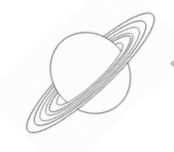
- Using the table, calculate (in Astronomical Units) the distance from:
- Earth to the sun
- Sun to Neptune
- Earth to Mars
- Earth to Pluto
- Jupiter to Saturn
- Earth to Ceres

- How far would a “round-trip” be in Astronomical Units
________ a. from Earth to Mars and back
________ b. from Earth to Mercury and back
________ c. from Earth to Saturn and back
________ d. from Earth to Pluto and back

