The Life Cycle of a Star: Star Death
Word bank: unstable, gravity, cooler, supernova, white dwarf, star, black hole, hydrogen, oceans, yellow hotter, temperature, space, life, planets, expand, explosion, red giant, collapse, large

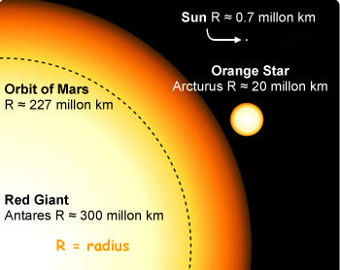
The Death of Small and Medium-sized Stars
In about 4 to 5 billion years from now the Sun will begin to exhaust its supply of …………. fuel.
The Sun's core will then collapse under its own ……………. as the outward pressure of the core decreases (because fusion reactions deep within the core are less prevalent). This will make the core …………. . Its atmosphere (the outer atom nuclei) will become …………… because of the increased pressure from the hotter core and start to ……………….
This will transform the Sun into a huge …… ………… star.
The increased amount of energy will be spread out over a larger area so each square metre will be ………….
The surface will have a red colour because it is so much cooler than it was at the ………… stable stage and will be much further from the centre than during the main sequence.
Our Sun will swell in size to encompass the inner …………... (perhaps Earth too) when this happens!
Despite its cooler surface ……………....., a red giant is very luminous because of its enormous surface area; so even if the Earth is not swallowed up when our Sun becomes a red giant, conditions on the planet will become impossible for ………. to exist. The surface temperature would be so high that the …………. and atmosphere would have evaporated away.
Finally, when the fuel runs out completely the crushing force of gravity makes the star …………… under the force of its own weight; as it is a relatively small star, it will collapse gently and remain collapsed. Such a collapsed star, at its life's end, is called a ………. ……………. Our Sun will probably end its life in this way.

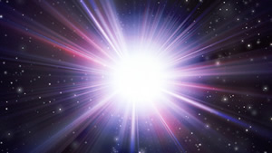
The Death of Large Stars
A different fate awaits a ………… star. Its final collapse generates a violent explosion, blowing the innards of the star out into space - this is called a ……………….
This is a really violent ………………… and is seen as a star increasing in brightness to very bright star. During this supernova event fusion of nuclei cause large nuclei to form - larger ones than would form in a small star.
The materials of the exploded ……… are flung out into ……….. and mix with the primeval hydrogen of the universe as dust. Later in the history of the galaxy, other stars are formed out of such clouds of dust and gas - nebulae (see above) and the whole cycle begins again.
After the supernova has blown all of the atoms from the outer star into space the dense core becomes a neutron star or even a ………… ………….
Our Sun and solar system contains the debris of countless other stars that exploded before the Sun was born. The heavier elements that are in our solar system - and you! - are star dust. As the 60s hit says - 'We are stardust!'

