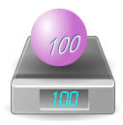
Weight or Mass?
Q: Aren't "weight" and "mass" the same?
A: Not really. An object has mass (say 100 kg). This makes it heavy enough to show a weight of "100 kg".

Gravity causes Weight
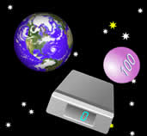
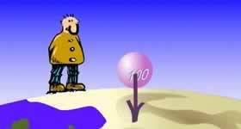
An objects weight is how hard gravity is pulling on it. We think the weight is the same everywhere ... because we all live on the surface of the planet Earth! However, in orbit it would not push on the scales at all. The scales would show 0 kg ... but the mass is still 100 kg. An object's mass doesn't change (unless you remove some!), but its weight can change.

So Why Do People Say Weight instead of Mass?
People often use "weight" to mean "mass", and vice versa. Since gravity is pretty much the same everywhere on Earth, we don't notice a difference. Remember…they do not mean the same thing, and they can have different measurements.
Here are some conditions where the weight might change:
- in space (can be weightless!)
- on the moon (a 100 kg mass would weigh 16.6 kg)

Weight is a Force
If weight and mass are different, why are they both in kilograms? Well, weight should not really be in kilograms!
I have used "kilogram" so far because that is what you would see on a pair of scales, but it is technically wrong to talk about weight in kilograms. There is a better measurement: Newtons

Newtons
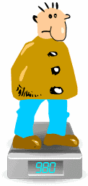
The correct unit for force is the Newton (=1 kg·m/s²) which is abbreviated N.
Gravity makes a 1 kilogram mass exert about 9.8 Newtons of force
So a 100kg mass really weighs about 980 Newtons on Earth.

Why Scales Show Kilograms or Pounds
Scales show Kilograms or Pounds because that is what people understand best...but it is really just an estimate of the mass above them. Scales should really show Newtons, but that might confuse people!
Question: how many Newtons should the scales show when you stand on them (hint: multiply kg by 9.8)?
- So the scales show an estimate of your mass based on the force your body exerts on it.
- To find out how much force your body is exerting on the scales, multiply by 9.8 (to convert kg into Newtons).

Apparent Weight
Scales can be fooled, because they measure a "downwards force" and don't know if it is gravity or some other force!
Just jump up and down (gently!) on your scales at home to see your apparent weight change, while your mass stays the same.
So your mass is the same, and your weight is the same (because the force of gravity hasn't changed), but your "apparent" weight changes.

Questions
- Neil weighs 750 Newtons (750 N) on Earth.
  - What is Neil’s mass?

  - On the planet Mars, the force of gravity is 3.73 N/kg. How much would Neil weigh on Mars?

- Buzz has a mass of 70 kg.
- What is his weight on the Earth (in Newtons)?

- What is his weight on the Moon, where the gravitational force is 1.62 N/kg?

- Valentina has a mass of 55 kg.
  - What is her weight on the Earth (in Newtons)?

  - What is her weight on Mars, where the gravitational force is 3.73 N/kg, to the nearest whole number?

