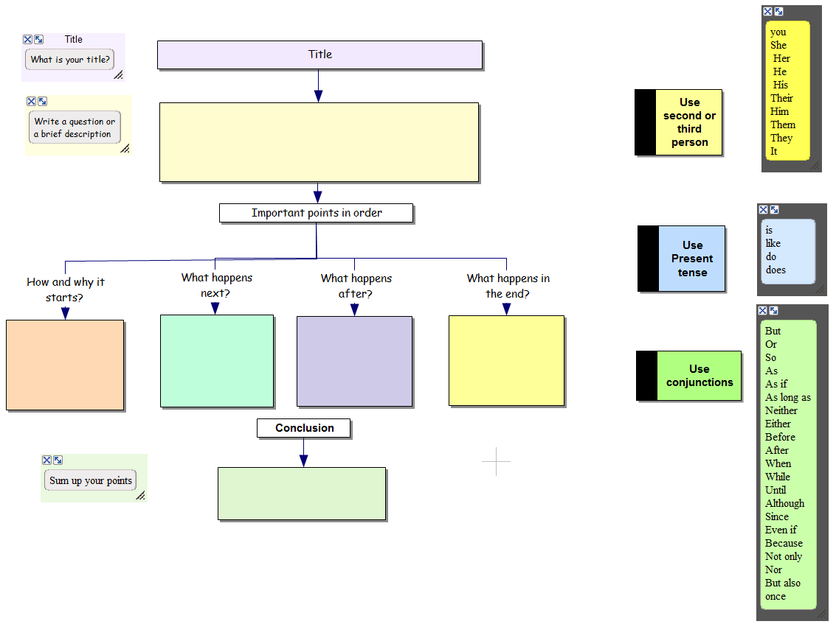
Writing Task
- Write a paragraph to explain the basics of a black hole.
- Information to include in your answer:
  - Explain how a black hole is born/formed.
  - Use astronomical terms in explaining the stages that result in a black hole forming. Such terms would be “supernova, interstellar, etc.”
  - Explain what a black hole is, and why it is named the way it is.
  - Explain how gravity is involved in black holes.
  - Why can’t light escape?

Have I
Written in the present tense?
Written in second and third person?
Written an introduction that asks a question or gives a brief description?
Said ‘How or why it starts’?
Said ‘what happens next and after’?
Said what happens in the end?
Written a conclusion with a summary, or a comment?
Have I used other words for ‘and’?
Have I used action verbs?
Have I used technical or scientific words?

